**Staff Guide: MySQL Coding Playground**

# Log in

### Go to [INSERT staff_login.php link] or click on ‘Staff Login’ on top right of page.

### Enter user and password. [INSERT admin credentials]

### You will be taken to the dashboard page which has admin options.

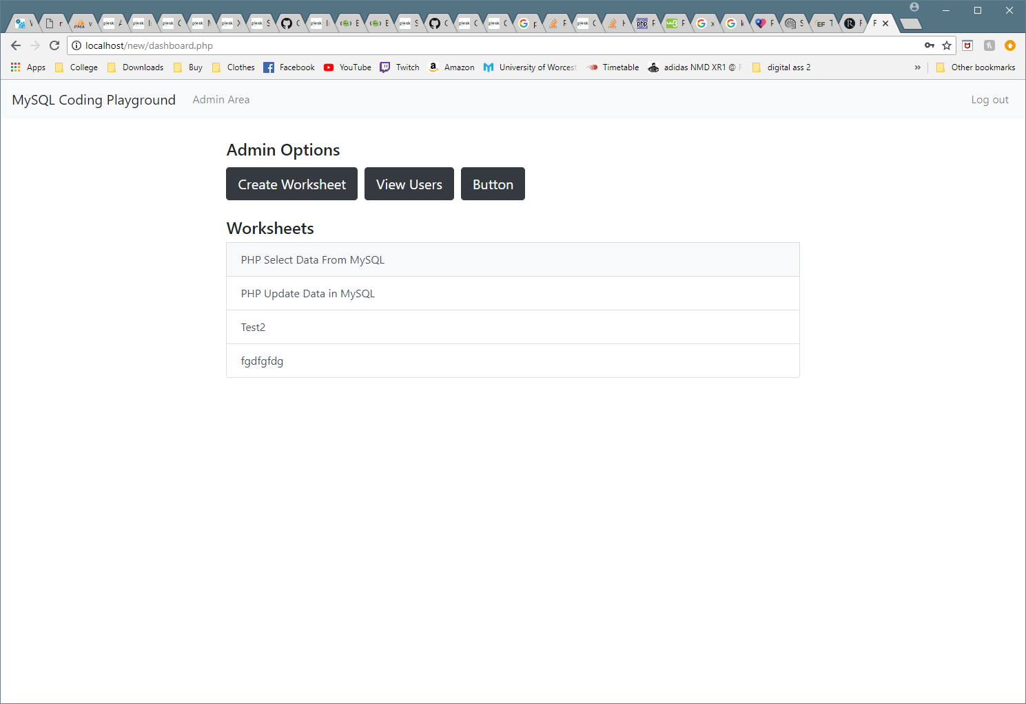

# Create Worksheet

### Click ‘Create Worksheet’ button



### Enter a name for the worksheet.

### If that file name already exists an error will be displayed, if so try again with a different file name.

### You will then be taken to a form that allows you to add or remove elements to the worksheet you are creating. (Examples of how elements look in example section at the end of this document)

**Use the red ‘Delete’ button to remove an element.**

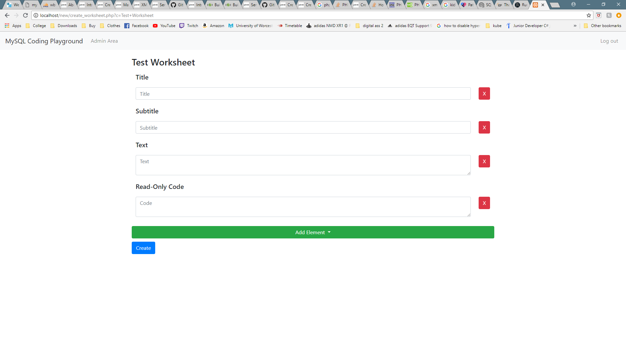**Use the green ‘Add Element’ button to add a new element.**

### Click the ‘Create’ button under add element to create the worksheet.



### You will then be taken to the worksheet (this is what the student will see minus the three admin buttons). The buttons can be used to go back to the dashboard, edit the worksheet, or delete the worksheet.

### The URL of this page can be given to students for them to use the worksheet.

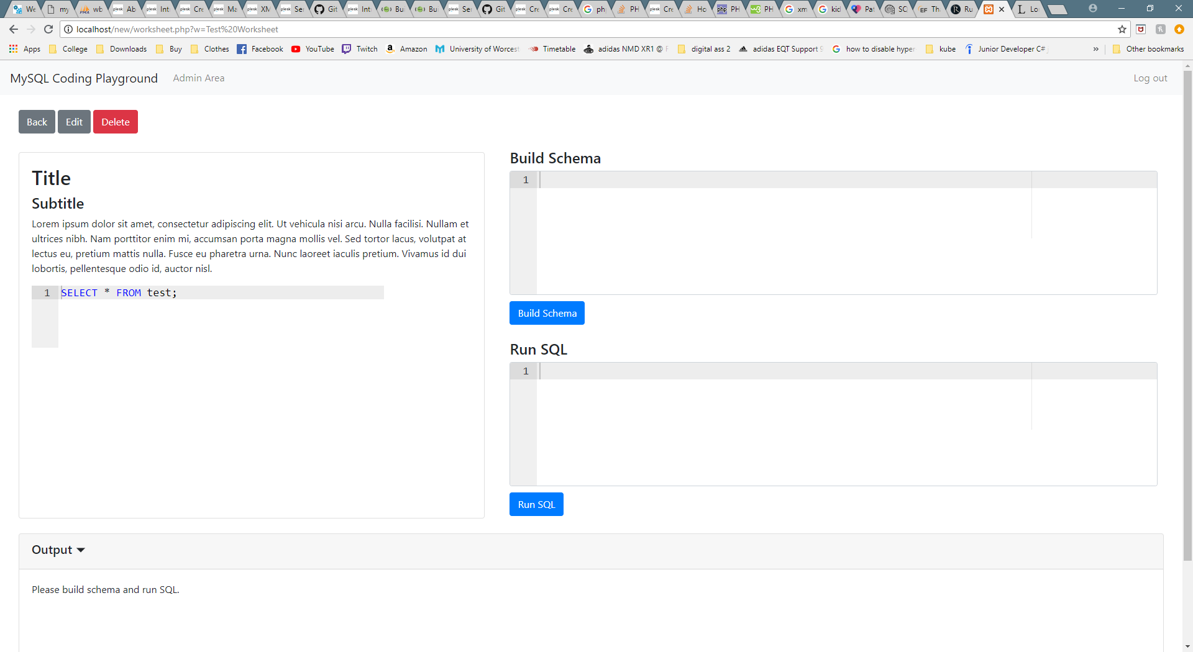

# Editing and Deleting Worksheets

### From the admin area (dashboard), select a worksheet by clicking on it.

### You will then be taken to that worksheet, here you can select Edit or Delete.

**WARNING: Clicking the ‘Delete’ button is irreversible, and all data will be deleted.**



### If you selected edit, you will be taken to the worksheet form where you can add or remove elements from the worksheet (as shown in the Create Worksheet section above).

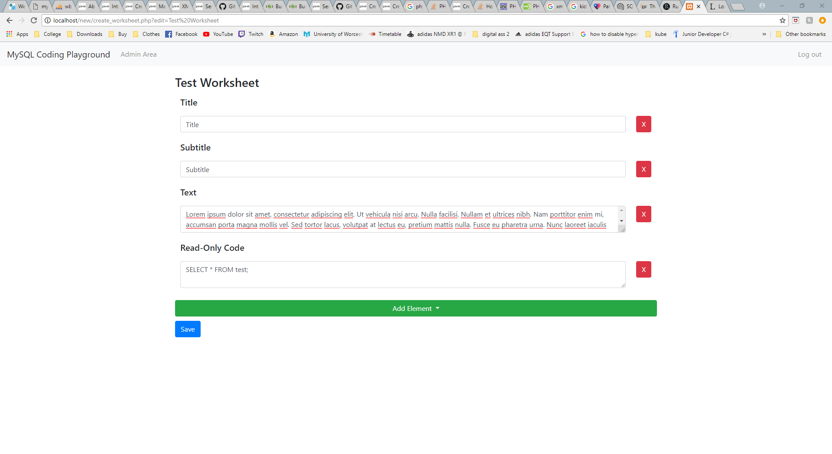

### After making changes, make sure you click the ‘Save’ button under the ‘Add Element’ button or your changes will not be saved.



# Worksheet Example

### Below is how the above configuration would look after being created. Each input on the worksheet form above corresponds to an element on the worksheet.

If you have any questions or need any help please email me at: rosb1_17@uni.worc.ac.uk